Exp 7

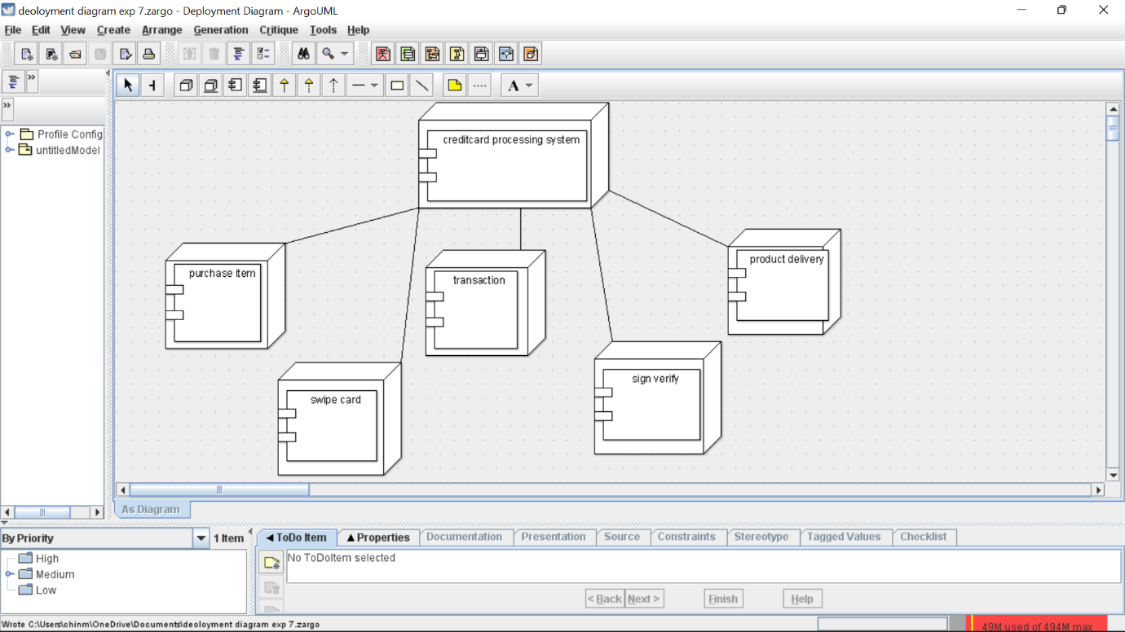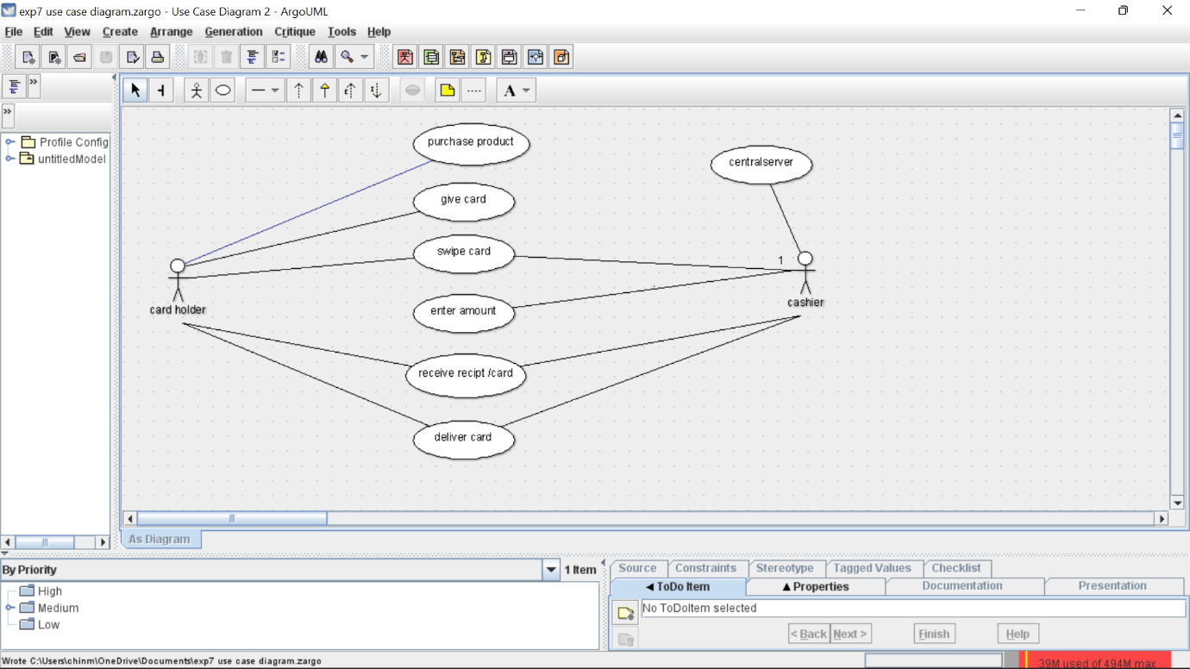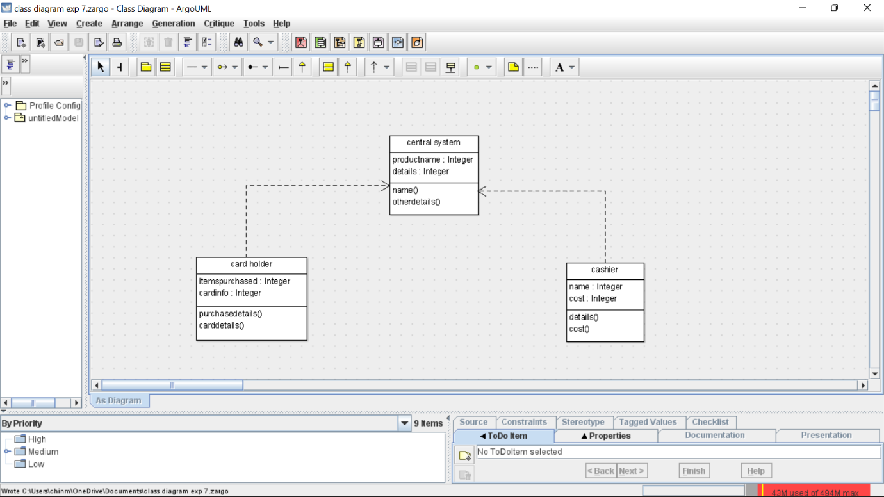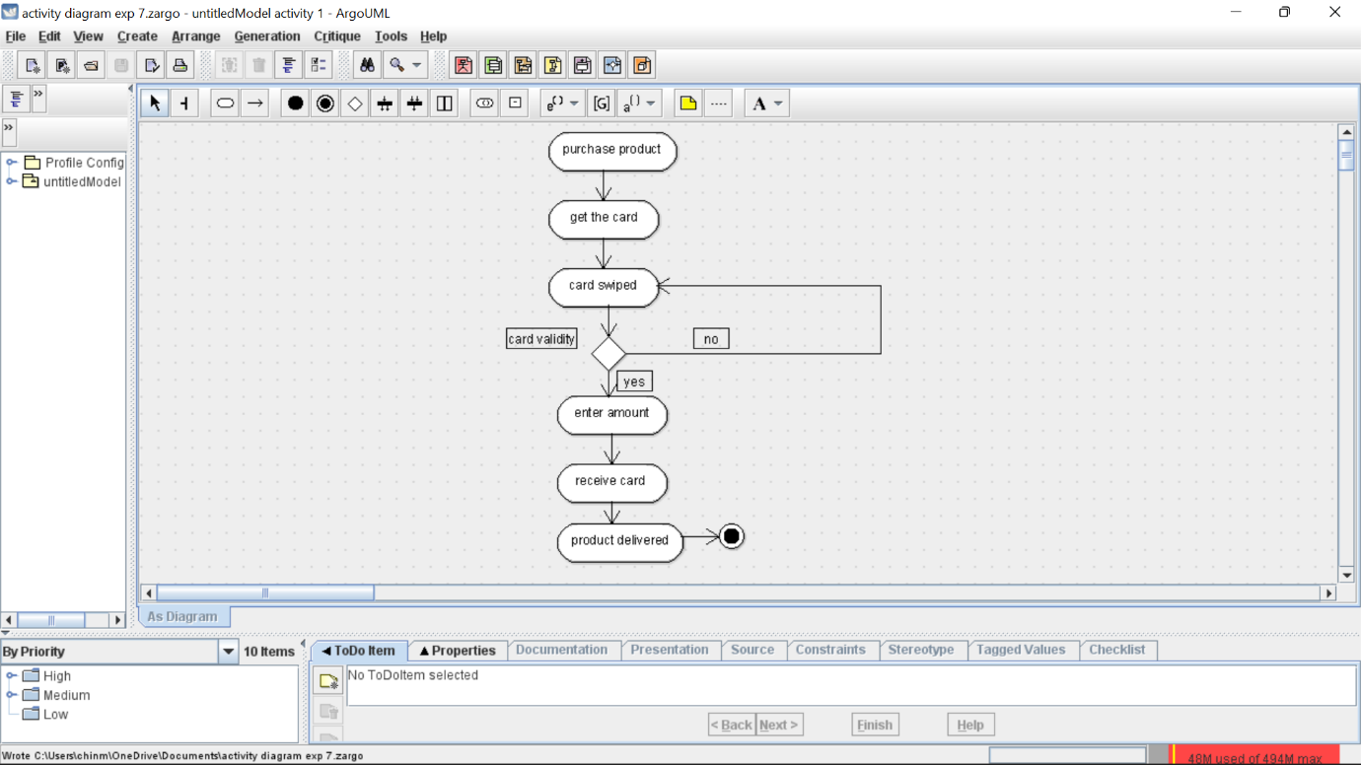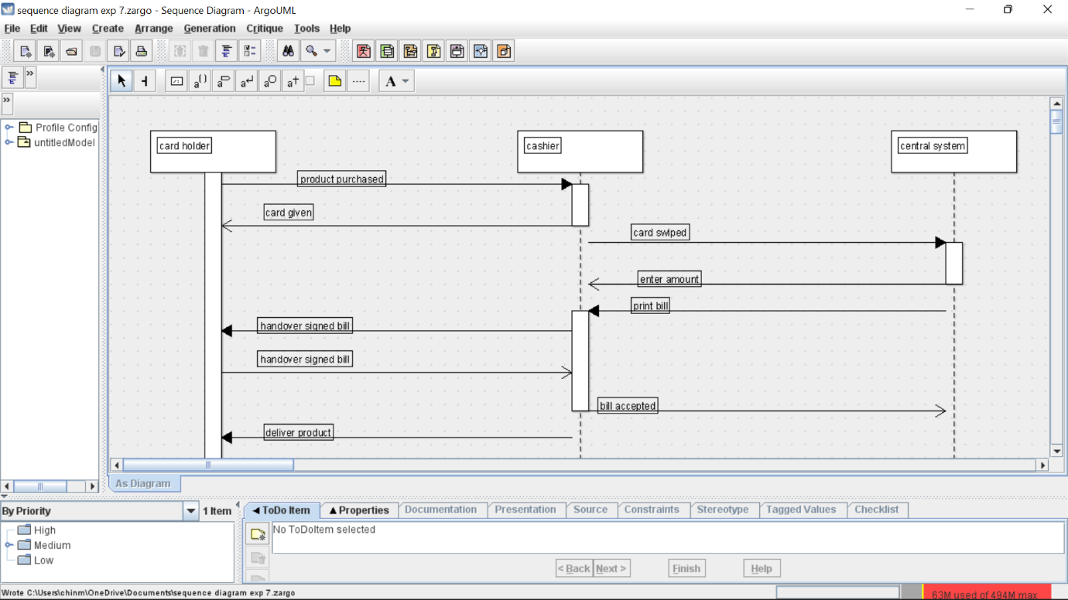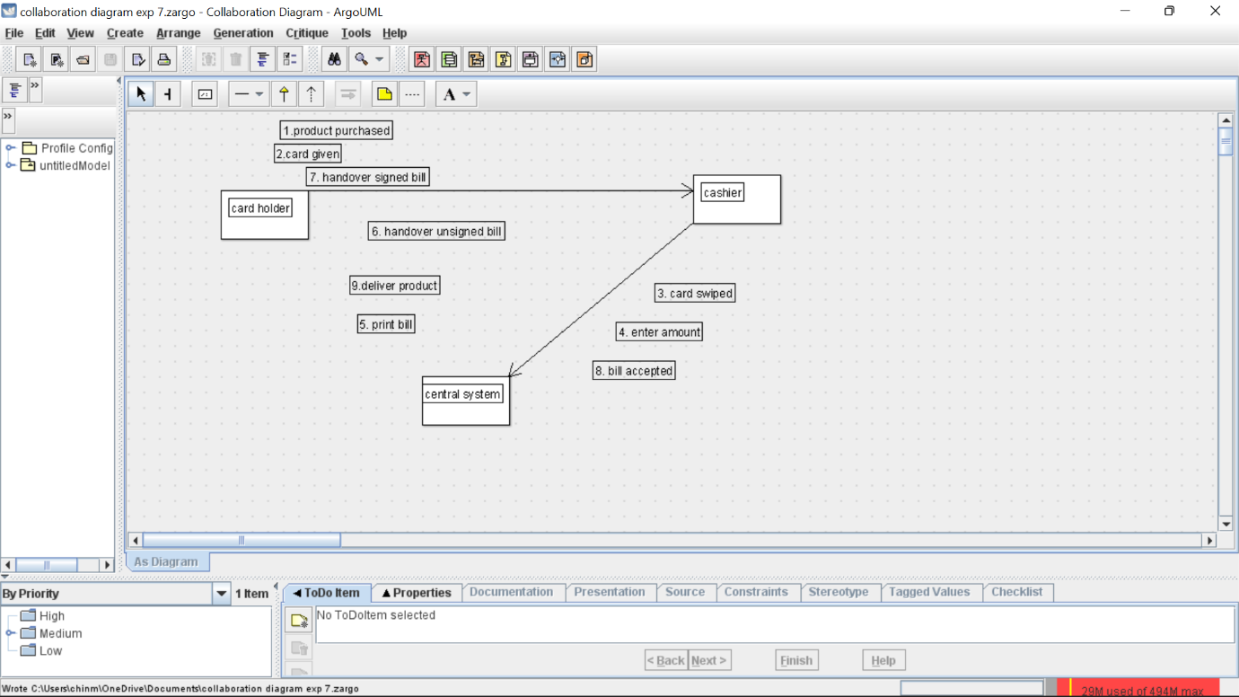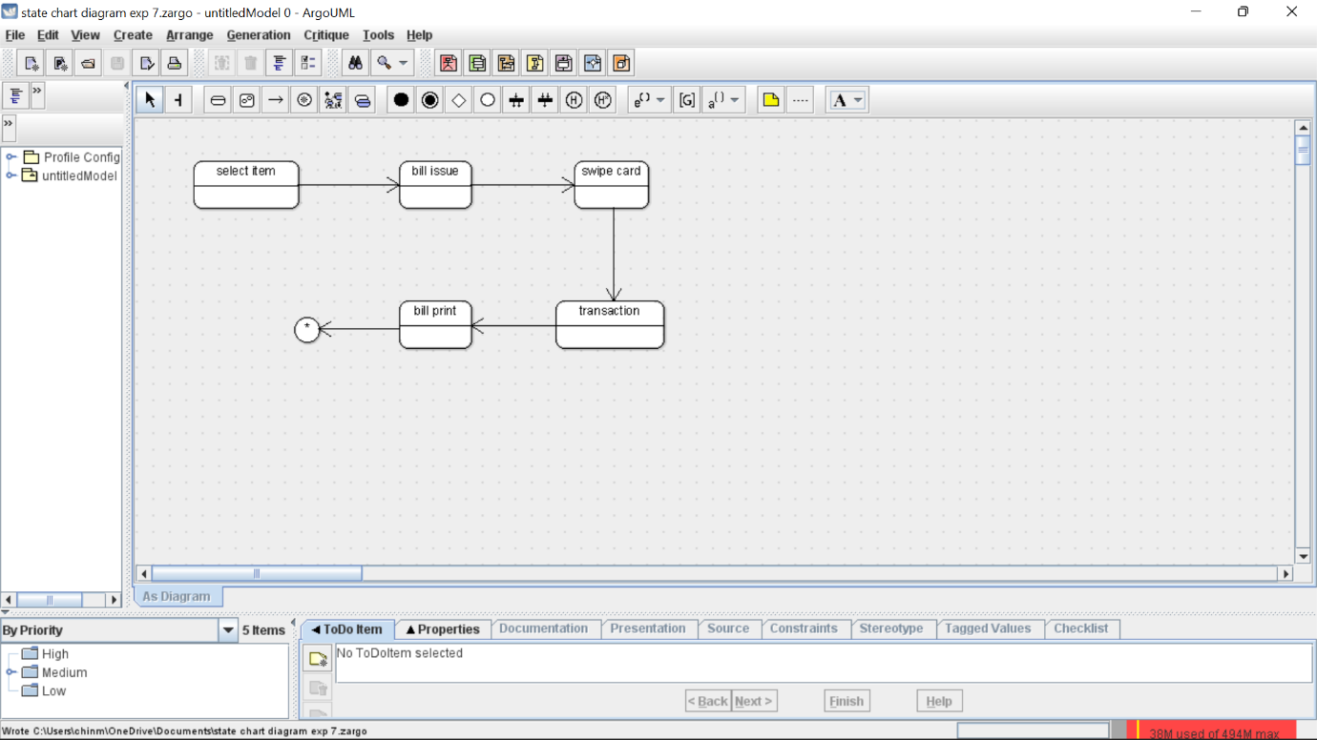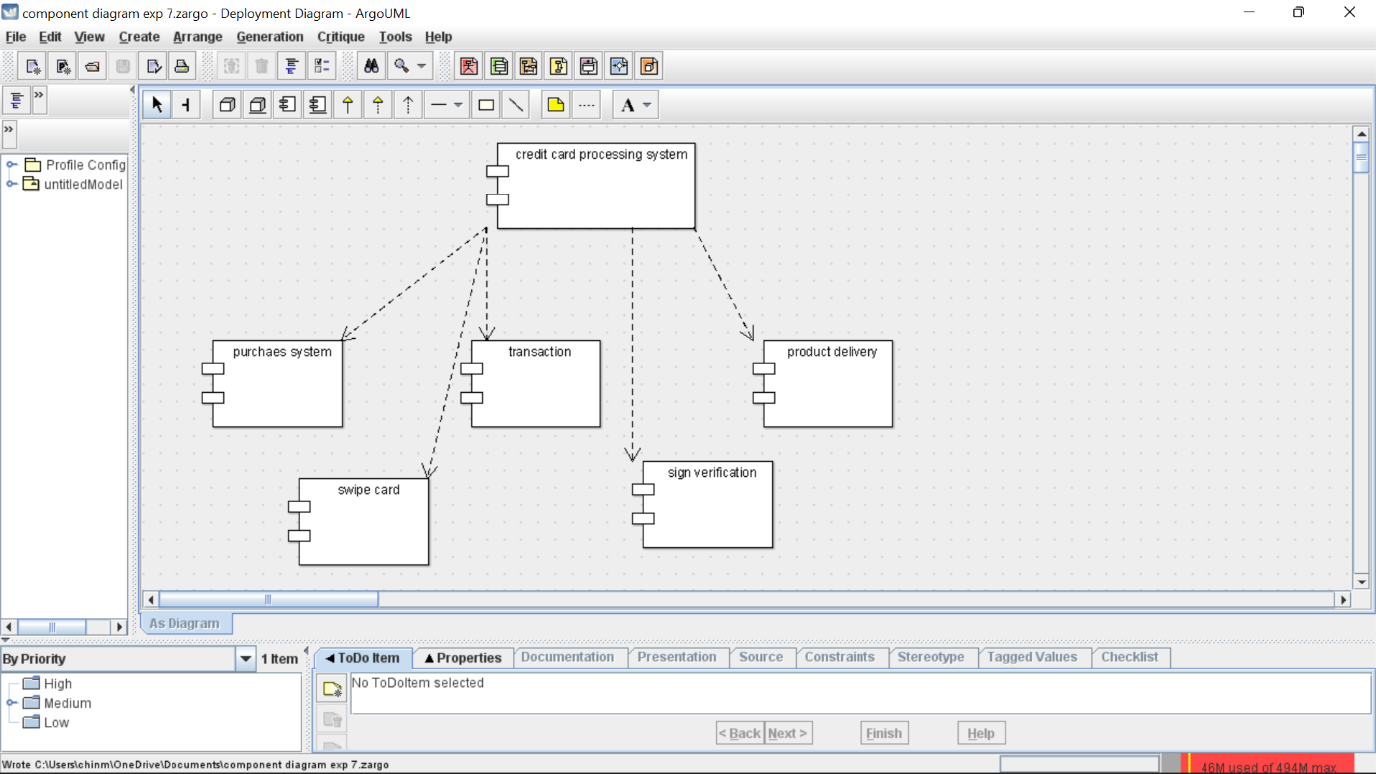

Skeleton

public class card holder {

public Integer itemspurchased;

public Integer cardinfo;

public void purchasedetails() {

}

public void carddetails() {

}

}

public class cashier {

private Integer name;

public Integer cost;

private void details() {

}

private void cost() {

}

}

public class central system {

private Integer productname;

private Integer details;

public void name() {

}

public void otherdetails() {

}

}